One of the biggest innovations that have taken place in the African continent in decades is the *M-Pesa* program. In Kenya, 72% have a mobile money account (Piper, 2020), largely due to M-Pesa (Weller, 2020). The M-Pesa program allows its users to transer money without having bank accounts ("M-Pesa", 2020). Additionally, it offers other banking services, such as loans, savings accounts, and more ("M-Pesa", 2020).

There are many reasons why the program is so great. Firstly, the increase in productivity and conveninence for Kenyan, and other african nations’ citizens have been substantial. Here is a quote from a Kenyan entrepreneur:

*“M-PESA has changed my life; it helps me make savings. I don’t need to travel to and from the bank every now and then because I can now deposit and withdraw from my bank account using the M-PESA platform. Previously, I used to make between five and ten trips to the bank in a week. I rarely visit my bank anymore,” says Mr Mungai, shop owner.* (Harris, 2020)

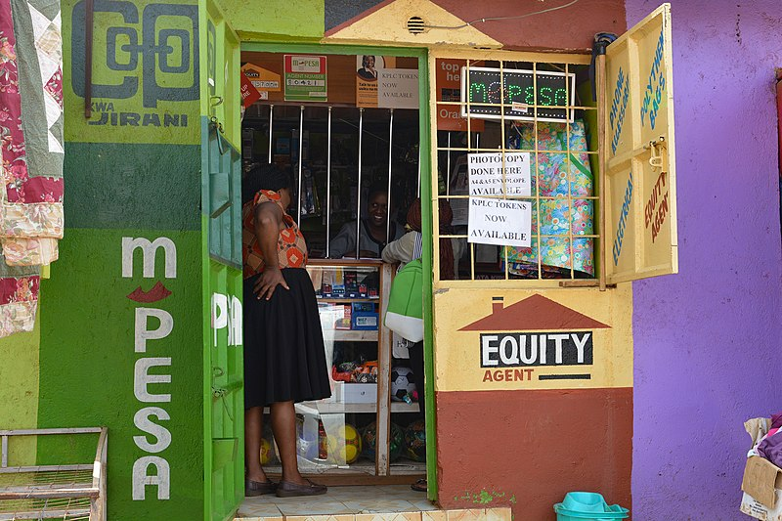

Secondly, the innovation has increased the safety for the recipients (Fernandes, 2020). This is both because of the fact that M-Pesa users to not have to carry their entire wage with them back to their village, or send the money with buses, both of which are common problem many people in the African continent face (Add reference). Lastly, the M-Pesa service has inspired and enabled other African entrepreneurs and businesses to chase their dreams (S., 2020).

M-Pesa is the perfect example of what can be done if entrepreneurs with great ideas are given the tools they need to get their business up and running. We want to enable similar innovations and entrepreneurs through our platform. **Click here to see how to try to make innovation happen on the African continent.**

M-Pesa. (2020). Retrieved 19 November 2020, from <https://www.vodafone.com/what-we-do/services/m-pesa>

Piper, K. (2020). What Kenya can teach its neighbors — and the US — about improving the lives of the "unbanked." Retrieved 19 November 2020, from <https://www.vox.com/future-perfect/21420357/kenya-mobile-banking-unbanked-cellphone-money>

Harris, L. (2020). M-PESA: how Kenya took the lead in mobile money. Retrieved 19 November 2020, from <https://www.mobiletransaction.org/m-pesa-kenya-the-lead-in-mobile-money/>

Fernandes, A. (2020). OpenIDEO - How might we use the power of communities to financially empower those who need it most? - M-Pesa: mobile money transfer solution. Retrieved 19 November 2020, from <https://challenges.openideo.com/challenge/financial-empowerment-challenge/research/m-pesa-mobile-money-transfer-solution>

Weller, C. (2020). A mobile banking service is transforming how the poor transfer money — here's how it works. Retrieved 19 November 2020, from <https://www.businessinsider.com/personal-finance/mpesa-transforming-how-poor-people-use-money-walk-thru-2017-12?r=US&IR=T#the-final-step-is-decidedly-low-tech-the-agent-enters-the-transaction-into-a-logbook-for-safe-record-keeping-the-threat-of-petty-crime-still-necessitates-some-old-school-precautions-12>

S., T. (2020). Why does Kenya lead the world in mobile money?. Retrieved 19 November 2020, from <https://www.economist.com/the-economist-explains/2015/03/02/why-does-kenya-lead-the-world-in-mobile-money>

Graham, F. (2016). File:M-PESA mobile money and Equity agent, Nairobi, Kenya.jpg - Wikimedia Commons. Retrieved 19 November 2020, from <https://commons.wikimedia.org/wiki/File:M-PESA_mobile_money_and_Equity_agent,_Nairobi,_Kenya.jpg>

Add reference <https://www.findevgateway.org/sites/default/files/publications/files/mfg-en-paper-mobile-payments-in-kenya-findings-from-a-survey-of-m-pesa-users-and-agents-jan-2009.pdf>